Python Programming Assignment: Mastering Array

Student Name: Faraz Ul Hassan Jehangiri
Date: 21-01-2026
Part 1: Lists (The "Shopping List")
Lists are ordered and you can change them (add, remove, or edit items).
- Create and Print: Create a list named fruits with "apple", "banana", and "cherry". Print the whole list.
Code:
fruits=["apple", "banana", "cherry"]
print(fruits)
Output:
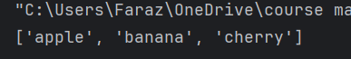

- Add Items: Use the .append() method to add "orange" to the end of your fruits list.
Code:
- fruits.append("orange")
Output:
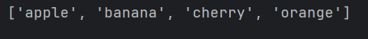

- Specific Change: Change "banana" to "blueberry" by using its index (position).
Code:
fruits[1]="blueberry"
print(fruits)
Output:

- Length: Use the len() function to find out how many items are in your list.
Code:
print(len(fruits))

Output:


- Remove by Name: Use the .remove() method to delete "apple" from the list.
Code:
fruits.remove("apple")
print(fruits)

Output:
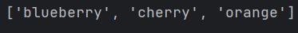

- Remove by Position: Use del or .pop() to remove the very last item in your list.
Code:
fruits.pop(2)
print(fruits)

Output:
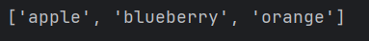

- Slicing: Create a list of numbers from 1 to 5. Use slicing to print only the first three numbers.
Code:
num=[1,2,3,4,5]
print(num[:3])

Output:
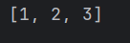

Part 2: Tuples (The "Locked List")
Tuples are ordered but cannot be changed after they are created.
- Create a Tuple: Create a tuple named coordinates with two numbers, like (10.5, 20.0).
Code:
tup=(10.5,20.0)
print(tup)
Output:
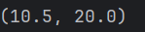

- Accessing: Print the first item in your coordinates tuple.
Code:
tup=(10.5,20.0)
print(tup)
print(tup[0])
Output:
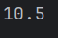

- The Error Test: Try to change the first item of your tuple to a different number. Write down the name of the error Python gives you.
Code:
tup[0]="faraz"
Output:
TypeError: 'tuple' object does not support item assignment

- Check Existence: Create a tuple of colors. Use an if statement to check if "red" is in the tuple.
Code:
colors=("red","orange","brown")
if "red" in colors:
print("Red maujood.")
else:
print("red not maujood.")

Output:
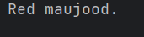

- Tuple to List: You have a tuple t = (1, 2, 3). Convert it into a list so that you can add a number to it.
Code:
t = (1, 2, 3)
lst=list(t)
lst.append(9)
print(lst)
Output:
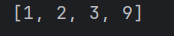

- Unpacking: Given person = ("Alex", 25), "unpack" these into two variables: name and age.
Code:
person=("Alex",25)
name=person[0]
age=person[1]
print(person,name,age)
Output:

Part 3: Sets (The "Bag of Unique Items")
Sets are unordered and do not allow duplicate items.
- Create a Set: Create a set called my_numbers with the values {1, 2, 3, 2, 1}. Print it and explain why it looks different than what you typed.
Code:
my_number={1,2,3,2,1}
print(my_number)
Output:
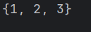
Looks different as it removed duplicates and is unordered.

- Adding: Use the .add() method to put the number 10 into your set.
Code:
my_number.add(10)
print(my_number)
Output:
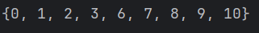

- Set Difference: You have set_a = {1, 2, 3} and set_b = {3, 4, 5}. Use the - operator to find what is in set_a but NOT in set_b.
Code:
seta={1,2,3}
setb={3,4,5}
print(seta-setb)
Output:

- Intersection: Using the same sets above, use the & operator to find the numbers they both share.
Code:
seta={1,2,3}
setb={3,4,5}
print(seta&setb)
Output:

- Clear: Use a method to remove all items from a set at once.
Code:
seta.clear()
print(seta)
Output:

Part 4: Review & Logic
- Mixing Types: Create a list that contains a tuple and a set inside it.
Code:
lsst=[{1,2,3},(5,6,7)]
print(lsst)
Output:
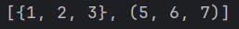
- The Choice: If you wanted to store a list of usernames where no two names can be the same, which would you use: a List, a Tuple, or a Set? Why?
Answer:
Set will be used as it doesn’t allow duplicates.

